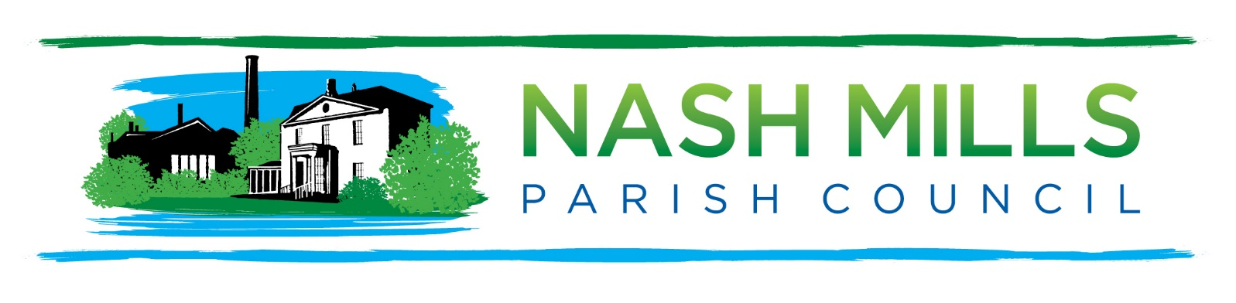
Annual Parish Meeting (APM)
Monday 13th May 2024 7.30pm
Nash Mills Village Hall
Minutes

- Welcome and Introduction.
Cllr Lisa Bayley as chairman welcomed everyone to the meeting.
Public Participation
6 councillors serving on Nash Mills Parish Council were present, along with the parish clerk and no members of the public.
- Minutes of Last Meeting.
The minutes of the last APM meeting 15th May 2023, were accepted as a true record of proceedings and were duly signed.
- Annual Reports (circulated in advance)
Council annual reports were circulated in advance and will remain available on the parish website.
The chairman thanked all contributors for the work in preparing the parish reports.
The chairman thanked the clerk and the warden for all of their efforts in delivering projects and services throughout the year
- Date of Next APM.
The date is likely to be Monday 12th May 2025

………………………………
Chairman
12th May 2025

