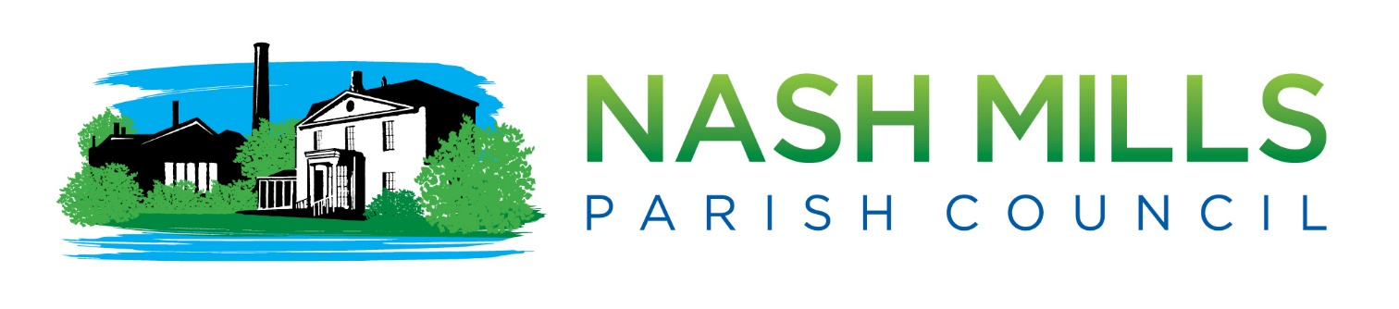

MEETING DATES FOR 2024/25

Date of Meeting
Monday 8th January 2024
Monday 12th February 2024
Monday 11th March 2024
Monday 8th April 2024
Monday 13th May 2024
Annual Council & Annual Parish Meeting
Monday 10th June 2024
Monday 8th July 2024
Monday 12th August 2024*
Monday 9th Sept 2024
Monday 14th October 2024
Monday 11th November 2024
Monday 9th December 2024*
Monday 13th January 2025
Monday 10th February 2025

*Meetings will only take place if deemed necessary

All meetings usually take place at Nash Mills Village Hall on Lower Road.
They commence at 7.30pm.
The latest and information and agenda can be found on our website
www.nashmillsparishcouncil.gov.uk

