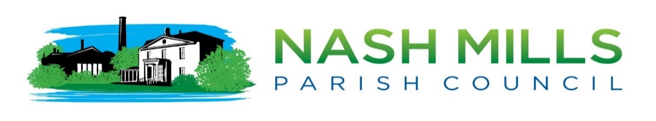

# **Clerk Report Annual Meetings March 2024**

## Clerk Information for new councillors.

This report is included to enable new councillors to distinguish the difference between the Annual Parish Meeting (APM) which is a meeting of the electorate and the Annual Council Meeting (ACM), which s the annual meeting of NMPC. New Councillors will have attended their first ACM and APM last year after the May elections.

NMPC traditionally hold these meetings on the same evening in May

Agendas from the previous meetings are attached as an example.

## **Background**

**Annual Parish Meeting (England) [1]**

The Local Government Act 1972 Part III requires that All Parish and Town Councils throughout England are required by law to hold an Annual Parish Meeting, which must take place between 1st March and the 1st June (inclusive). Meetings should not commence before 6.00 pm.

The Annual Parish Meeting is a meeting of all the local government electors for the Parish, which the public are entitled to attend and participate in. It is **NOT** a parish council meeting. It is usually convened by the council.

The meeting acts as an annual democratic point of communication enabling the Parish Council to explain what it has been doing over the last year and providing an opportunity for the electors to have their say on anything that they consider is important to the people of the Parish.

Traditionally this is not a well-attended meeting therefore last year NMPC held a separate ‘Expo’ event to engage with the local electorate and to showcase NMPC projects, achievements, and plans. Annual reports are produced and shared via our website and social media.

**The Annual Parish Meeting (APM)**

* Must be held annually
* Legal requirement.
* It’s a meeting for the electorate
* More informal as limited statutory requirements
* Must be held between 1st March -1st June (inclusive)
* NMPC traditionally hold it on the same evening as the ACM
* Must not commence before 6pm
* Nash Mills meeting usually starts at 7.30pm
* Should include annual reports from Chairman, Committees, Warden, PCSO, Clerk
* guest speakers.
* Agenda is signed by Chairman-it’s an invitation not a formal notice to attend.
* Meeting is usually short (15 mins) with an extended refreshment section at the end for networking/ meet & greet

**Annual Meeting of the Parish Council (ACM)**

• Must be held annually

• Legal requirement

• It’s an official, formal meeting to transact business

• Must be held in May apart from election years

• Nash Mills meeting traditionally starts at 7.45pm

• Agenda is determined, drawn up and signed by clerk as it is official business only as per our standing orders ie election of Chairman/ election of members to committees/ checking of assets register etc.

• The finances will be included as they require monthly sign off

• Any planning matters will be included

• No additional business (unless deemed urgent by the clerk) will be included on the agenda as the agenda is very lengthy.

Nikki Bugden

28th March 2024

**Example of agenda for APM**

example of agenda for annual parish 
meeting

1. [Local Government Act 1972 (legislation.gov.uk)](https://www.legislation.gov.uk/ukpga/1972/70/schedule/12)