## 

## RFO Report Finance Q2 30th Sept 2022 (updated)

*Please note that* the *full financial figures are* listed at *the back of this document. These figures are missing the final NatWest bank interest payments which aren’t expected to be more than £10.These are from a third-party* software *programme and therefore are* not *able to* be *made accessible in* this *document. Please contact the clerk should you require* assistance.

### **Summary**

Nash Mills Parish Council (NMPC) is now at the end of the second quarter of the new financial year. Precept and grants have been received and as these were unknown at the time of budget setting result in the reports showing higher-than-expected income figures.

**Total balances held on accounts (less NatWest final interest payment) on 30th Sept 2022 £130250.52**

of which £84922 is currently earmarked, the ongoing projects are listed below.

The Denes Project

It is hoped that the project will continue in Autumn 2022 as final decisions re planters should be made at the October meeting. The Clerk met with the DBC Officer onsite and is waiting for final confirmation of start dates.

The Clerk is waiting for details of installation dates from the HCC Officer in relation to the cycle racks and noticeboard installation. The noticeboard has been delivered.

The Verges Project

Council will be urged to re visit the CIL reserves that have accrued over the term, some of which will require spending by 2025. This was due to be considered during the June meeting, however the at the time of writing this report the updates from HCC and DBC in relation to the verges project are still outstanding. The County/Borough Cllr has been asked to assist with the chasing of these outstanding items.

The Rewilding Project/Open Spaces Working Group

The Open Spaces working group lead has also been asked to consider proposals for the open spaces and play park within the parish, but council is still waiting for the lease negotiations to be concluded.

The Clerk and open spaces lead have met to discuss the strategy for working with DBC re planting/signage etc. and this will be fed back to council via the working group in due course.

Council’s third-party contractors (DBC/HCC) have been advised that NMPC would like to complete as much of these works as possible prior to the end of this council term in May 2023 but NMPC is unfortunately unable to control the scheduling.

CIL funding-other considerations

Council has received a funding request from HCC for towpath improvements and the sum of £5000 was approved as a donation to these works in the June meeting. This support could come from CIL monies; however, the Clerk has received a response from HCC to indicate that it is now revisiting the schedule of works and will come back to us in due course.

Council to note that CIL is a conditional spend.

*[1]The parish council must use the CIL receipts passed to it to support the development of the parish council’s area by funding the provision, improvement, replacement, operation, or maintenance of infrastructure; or anything else that is concerned with addressing the demands that development places on the area.*

Budget planning for 2023/2024

Council is now at the stage of looking at budgets for the year 2023/24 and the current volatile economic climate is causing concern, with the cost-of-living crisis, energy prices and recent interest rate rises making budget setting more difficult than usual. Whilst NMPC does not own premises to be affected directly it is anticipated that its suppliers will need to increase their prices to accommodate their uplift in costs. The salary award for this year has not yet been agreed by the unions but could see an additional increase of approx 10% for the budget year 2023/24.

NMPC undertook another rigorous review of expenditure last year as a means of keeping any precept increase as low as possible, however this means that there are no areas to reduce costs this when looking at budgets without affecting the services provided. It will be a matter for council to consider how/where it can save costs and the impact of any increases on the precept. Council is very fortunate that its precept is one of the lowest across Dacorum, but it has not yet received any confirmation from DBC as to whether there will be any impact on the grant funding this year; any decrease will also impact Council’s ability to balance its budget at the current precept level.

*At the time of writing this report the rate of inflation was showing at nearly 10%*

*Financial Headlines*

## Position 30th Sept 2022 (income/expenditure)

|  |  |  |  |  |
| --- | --- | --- | --- | --- |
|  | **Budget** | **Actual** | **Variance** | **Notes** |
| **Income** | 40742 | 45440 | (4698) | This difference is considerably less than last quarter report.  Budget keyed on software originally did not include precept, grants, or CIL monies as these were unknown at the time of budget setting and previous year’s figures were used to set the precept. Budget was adjusted to take into account precept and grants therefore difference is now caused by CIL receipts and £3000 grant received. |
| **Expenditure** | 42005 | 24811 | 17194 | Prudent use of reserves means council is at 59% of annual expenditure at the halfway point. There are no areas of concern at the moment, and it is expected that the year-end figures will be very close to actual budget. |

#### Budget Heading Overspends over £100 or 15% of budget (reported as required in our Financial Regulations)

* 4160- Misc. (Park &Misc.) £1830 unbudgeted but covered by earmarked reserves

*New bench cost/plaque and stake for tree/acrylic for noticeboard/Jubilee prizes, posters, art supplies. £100 park inspection (budgeted)*

* 4162- Sundry Exp- £382 unbudgeted but covered by earmarked reserves

*Jubilee bunting, biscuits, and stickers*

* 4301- The Denes Project - £1185 unbudgeted but covered by earmarked reserves- *Jubilee bench and plaque.*

#### Budget Heading Underspends over £100 or 15% of budget (reported as per our Financial Regulations)

Too early in the year to report under this heading. No concerns at present.

**Invoices Due**

Please note that all magazine advertising has now been paid for resulting in income of £732

*Nikki Bugden*

Clerk to the Council 30th Sept 2022

**Attached**

Earmarked Reserves 30092022

Bank reconciliation -All Accounts 30092022

Receipts and Payments details 30092022

Please note that documents from this point onwards are from third party software and are therefore not accessible. Please ask the clerk should you require additional formats.

## Earmarked Reserves

## 

## Bank reconciliation All Accounts – 30th Sept 2022

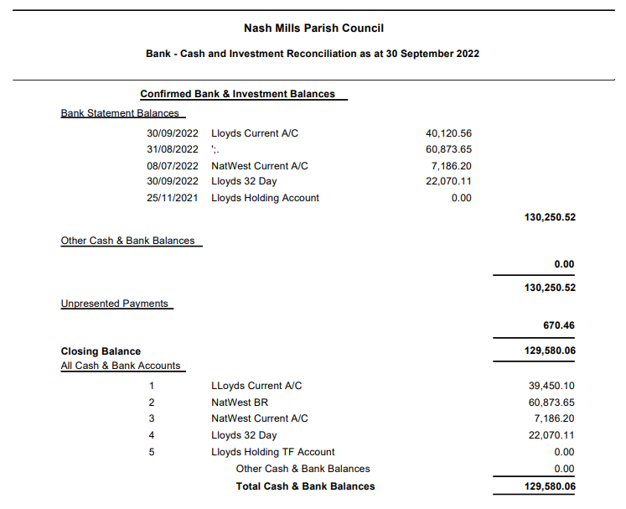

Budget Figures /Income Expenditure 30th Sept 2022

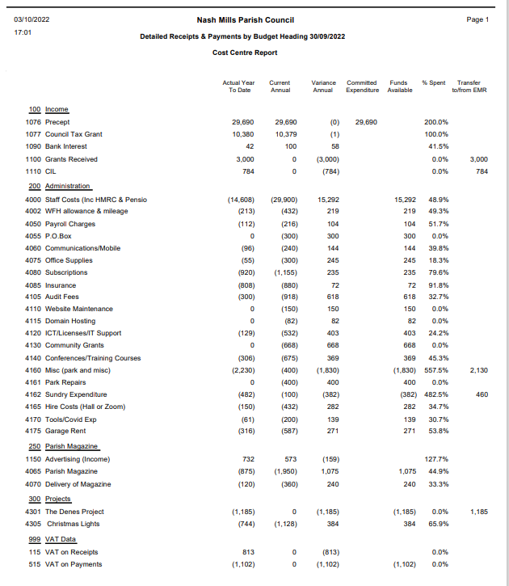

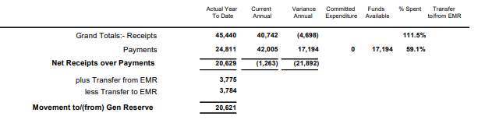

1. [Community Infrastructure Levy - GOV.UK (www.gov.uk)](https://www.gov.uk/guidance/community-infrastructure-levy#spending-the-levy)