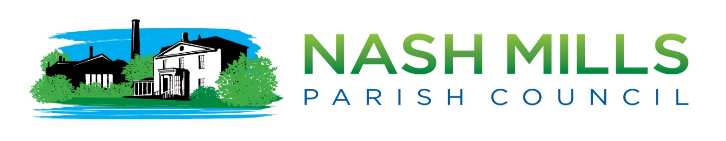

PO Box 1602 Hemel Hempstead Herts HP1 9ST E: clerk@nashmillsparishcouncil.gov.uk W:www.nashmillsparishcouncil.gov.uk

Councillors Lisa Bayley, Jan Maddern, Michele Berkeley, Alan Briggs, Nicola Cobb, Mandy Lester, Steve Roberts, Emily Tout

are hereby summoned to attend.

Nash Mills Parish Council Extra-Ordinary Meeting Monday 9th August 2021 7.45pm
Nash Mills Village Hall, Lower Road, Hemel Hempstead.
To transact the business on the following agenda

PLEASE NOTE- SAFETY ADVICE AND IMPORTANT INFORMATION BELOW
Members of the public and press are allowed by legislation to attend a parish council meeting, however during the current Covid-19 pandemic NMPC would advise any members of the public that they do so at their own risk. Face coverings must be worn. All supporting information and any decisions made will be available on our website.

Nikki Bugden

Mrs N Bugden

Clerk to Nash Mills Parish Council – 02/08/2021

To assist in the speedy and efficient despatch of business, members requiring further information or clarification on items included on the agenda are requested to enquire prior to the meeting. Please see our website or contact the clerk for accompanying reports.

AGENDA

21/092/FPC Apologies

21/093/FPC Interests

To receive any declarations of interest for items on the agenda or requests for dispensation.

21/094FPC To consider the appointment of an Honorary Freeman of the Parish of Nash Mills

21/095/FPC To consider the date and format of the presentation of this award

21/096/FPC To authorise the clerk to purchase an official scroll for this occasion.

From 12 January 2010, all local councils may exercise powers to confer the title of “Honorary freeman” or “honorary freewoman” to persons of distinction and those who, in the council’s opinion, have rendered eminent services to the council’s area (section 249(5) and (6) of the 1972 Act). The admission of an honorary freeman or honorary freewoman must be by resolution made at a meeting of the full council specially convened for such purpose and passed by no than less than two-thirds of the members of the council (Section 249(8) of the 1972 Act). That section also requires “notice of the object of the meeting” to be given. This confirms the need for the agenda with the public notice and summons to members in respect of the council meeting to itemise a motion to confer the title of honorary freeman or honorary freewoman. A local council may spend a reasonable sum as it thinks fit for the purpose of presenting an address or a casket containing an address to a person on whom it has conferred the title of honorary freeman or honorary freewoman (Section 249(9) of the 1972 Act).

