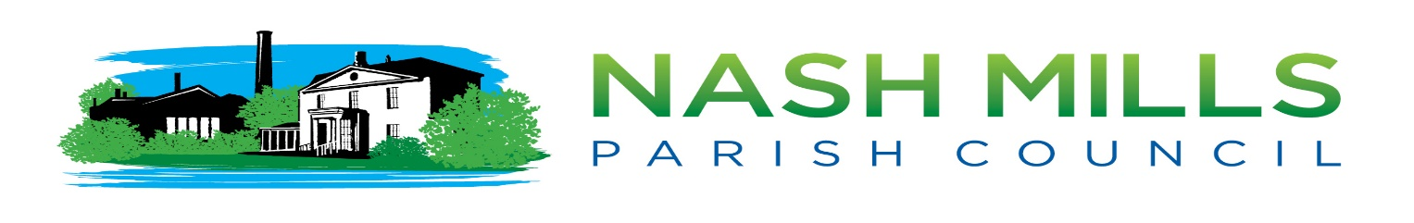

Clerk Report Remote Meetings Update April 2021

Recommendation
a) That NMPC agree to move the May meeting to either 4th/5th/6th May.
b) That NMPC agree to extending the emergency delegation under our published scheme of delegation 2.3, our standing orders and our financial regulations and will delegate all decisions to the proper officer. This will enable the proper officer to make decisions on behalf of, and in the best interests of the Council whilst meetings are not being held. If possible, the proper officer will liaise, in whatever format they deem appropriate, with the Chairman (or in their absence the Vice-Chairman).
The delegation does not extend to matters expressly reserved to the council in legislation, or matters that, the proper officer’s opinion, can be deferred to a later time. All delegated decisions are to be advised to council in writing and published at the next possible council meeting. For planning items, the clerk will seek opinions via email (or potentially zoom) and will submit majority decisions, whilst ensuring that the planning officer is aware that a council meeting has not been convened.
Background
The Local Authorities and Police and Crime Panels (Coronavirus) (Flexibility of Local Authority and Police Crime Panel Meetings) (England and Wales) Regulations 2020 (“The 2020 Regulations”) which permitted remote meetings expires 6th May 2021.

Govt. currently have no plans to extend the remote meetings legislation beyond that date as it would require a change in primary legislation, although there has been a ‘call for evidence’ from the Ministry of Housing, Communities & Local Govt. to facilitate further investigations following objections from our sector.

Herts County Council, The Association of Democratic Services Officers and Lawyers in Local Govt. are undertaking a legal challenge that meeting ‘in person’ could be interpreted to include virtually in modern times as the original act was passed in 1972 but at the time of writing this report this was still in progress with a decision hoped for by the end of April 2021.

For Consideration
Whilst matters are unresolved NMPC need to consider how best to continue operating until such time as we come out of lockdown completely (estimated to be 21st June 2021) and we can undertake a risk assessment that evidences that we can safely operate in the local hall whilst allowing full, un-restricted public access. We also have a duty of care to all attendees, staff, councillors, and public who may not be vaccinated.
Should a matter arise that requires consideration by full council the clerk will work with council to determine the appropriate way to conduct this-ie only having a quorum present, meeting taking place outside, adherence to the relevant Covid restrictions and safety measures.

Nikki Bugden
Clerk to the Council 30/3/2021

In an emergency the Proper Officer is empowered to carry out any function of the Council.
Delegation to clerk, LGA 1972 s101.
High Court challenge to allow local authority remote meetings beyond 6 May - 23rd March 2021 - Hewitsons Law Firm

