# **Clerk Report Councillor Audit Responsibilities April 2021**

Annually council sign off the Annual Governance Review (AGAR). This will be signed off once the financial year end has been prepared. Council should be happy that the assertions in the AGAR are correct.

NMPC has an audit plan and a framework of policies and procedures as evidence of a robust system of internal control. These are reviewed throughout the year and in November 2020 council resolved that there was an effective system of internal controls in place.

The assertions for 2020/21 financial year are listed on page 2.

Council should raise any questions relating to the AGAR in advance of the formal agreement. Further information relating to the accounting practises for parish councils can be found in the NALC Practitioners Guide.

[Microsoft Word - practitioners-guide-2020.docx (nalc.gov.uk)](https://www.nalc.gov.uk/library/our-work/jpag/3223-practitioners-guide-2020/file)

My comments in relation to assertion 1-9 are below

|  |  |
| --- | --- |
| **Assertion** | **Comments and Evidence** |
| 1 | Financial Regulations/Standing Orders/Risk Assessments in place |
| 2 | Financial Regulations/Standing Orders/Risk Assessments in place |
| 3 | Clerk advised of relevant ‘powers to spend’ and minuted. General Power Competence attained. |
| 4 | Actioned (website and noticeboard) |
| 5 | Financial Management and other risk assessments in place. Insurance in place |
| 6 | Audit completed (internal and external) |
| 7 | See page 3 onwards the only outstanding action is the historic VAT query. |
| 8 | All up to date. |
| 9 | n/a |

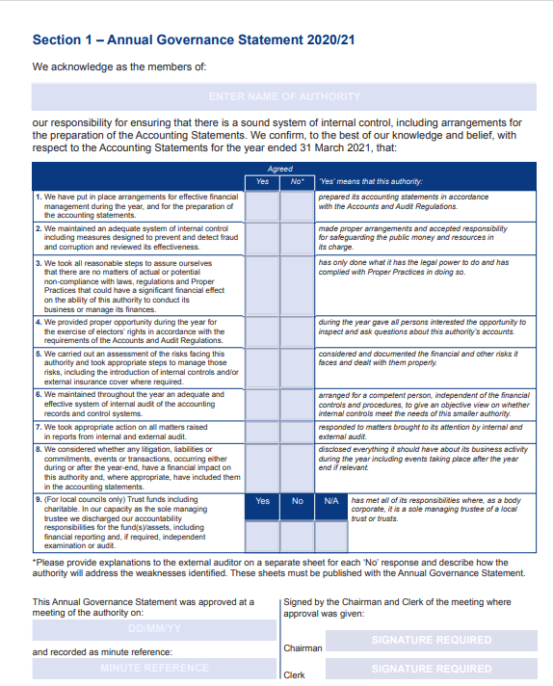

**

table showing auditor comments

Nikki Bugden

25th March 2021