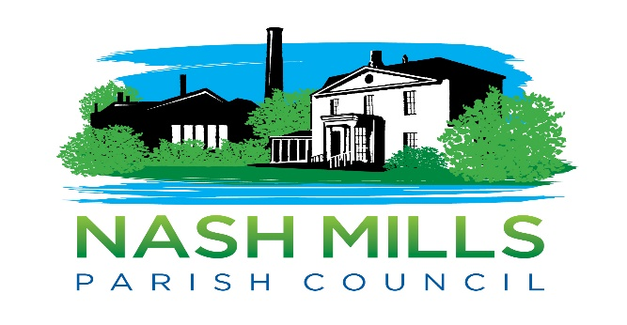
Full Parish Council Extraordinary Meeting Minutes
held on
22nd February 2021 via Zoom
Present
Councillor Lisa Bayley (Chairman)
Councillor Michele Berkeley
Councillor Alan Briggs
Councillor Nicola Cobb
Councillor Mandy Lester
Councillor Jan Maddern (for part of the meeting)
Councillor Steve Roberts

In Attendance
9 Members of the public
Nikki Bugden (Clerk)

21/001/EM Apologies
Councillor Emily Tout. Apologies noted.

21/002/EM Interests
To receive declarations of interest from councillors on items on the agenda.
None declared, however Cllr Maddern clarified that she would be attending in her Borough Councillor capacity only as she has previously publicly declared her views on the scheme and therefore could not consider the agenda item as a parish councillor without a pre-determined view.

21/003/EM Public Issues/Participation
No members of the public were registered to speak.
Borough Councillor Jan Maddern spoke at the invitation of the Chairman to provide historic background information relating to the proposed scheme and to inform council of a meeting next week with herself, Sir Mike Penning MP and Vistry to ascertain whether additional parking for the Nash Mills Wharf development could be made available. The suggestion is that Vistry consider the provision of the small area of green belt land behind the existing car park that could provide considerably more spaces than needed to accommodate the 30-40 cars who are currently parking on the road at Red Lion Lane. This would be subject to planning considerations.
Questions were then taken from councillors.
Borough Cllr Maddern left the meeting.
21/004/EM The Hertfordshire (London Road, Red Lion Lane, Hemel Hempstead and Rucklers Lane, Nash Mills Lane, Kings Langley) (Restriction of Waiting) Order 2021
https://www.nashmillsparishcouncil.gov.uk/wp-content/uploads/2021/02/D-011-20-Scan-Draft-Doc.pdf

A discussion was held and all councillors present were asked for their views in turn. The overriding view was that whilst NMPC would welcome double yellow lines, should alternative parking be made available, at this present moment in time there was no mitigation for the impact that losing these spaces would have on the already overwhelmed available parking provision within Nash Mills parish.
The potential for Nash Mills Village Hall to consider an income generating parking scheme was noted by the parish council representative.

RESOLVED, proposed Cllr Bayley, seconded Cllr Berkeley, that NMPC object to the proposal as it currently stands as NMPC cannot support a scheme without suitable alternative provision. Unanimous decision.

A further discussion was held relating to alternative solutions. Council agreed that short stretches of yellow lines around the traffic island and junctions were required as safety measures. Votes were taken on councillor’s suggested alternative considerations that had not received full agreement, including potential on street parking bays created by the removal of the footpath and verge with installation of electrical charging points.
Motion for removal of the footpath to offer on-street parking bays was not carried, following use of Chairman’s casting vote.
Action clerk to draft response.
Action clerk to add possible Vistry correspondence to March agenda.

………………………………………
Signed Chairman
Date………………………………

